**Install Oracle Software Database**

1. **Install Oracle Database**

* Oracle database **V839906-1**
* Put it in /home/sreyroth

1. **Move Oracle Database to Oracle user**

* mv Software/ /home/oracle/
* Provide permission to Software/ “**chown oracle:oinstall Software/**”
* Cd to Software/ & provide permission to **V839906-1 “chown oracle:oinstall V839960-01.zip”**
* Unzip **V839960-01.zip “unzip V839960-01.zip”**
* Cd Software/database “ls -F”
* Run command “. ./runInstaller” to run database 12C

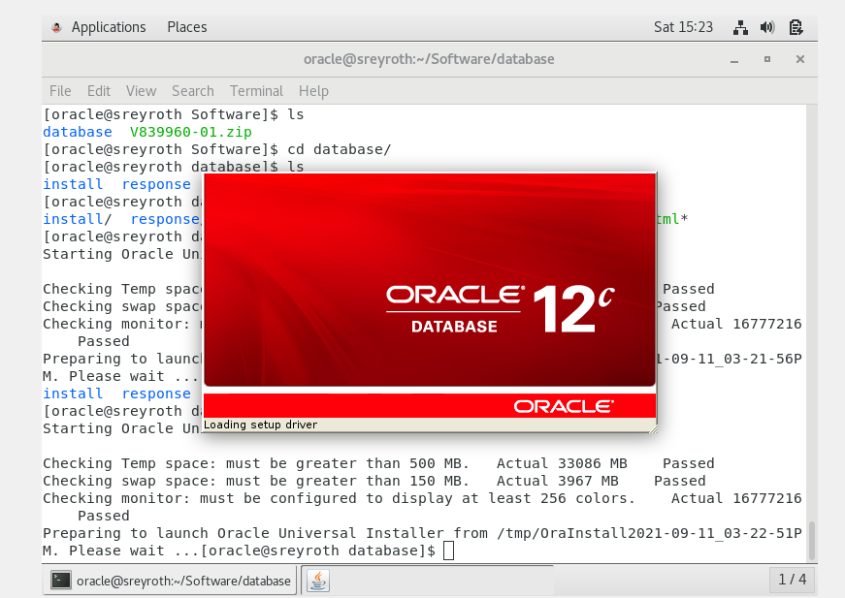

1. Oracle database 12C -> Untick-> Next

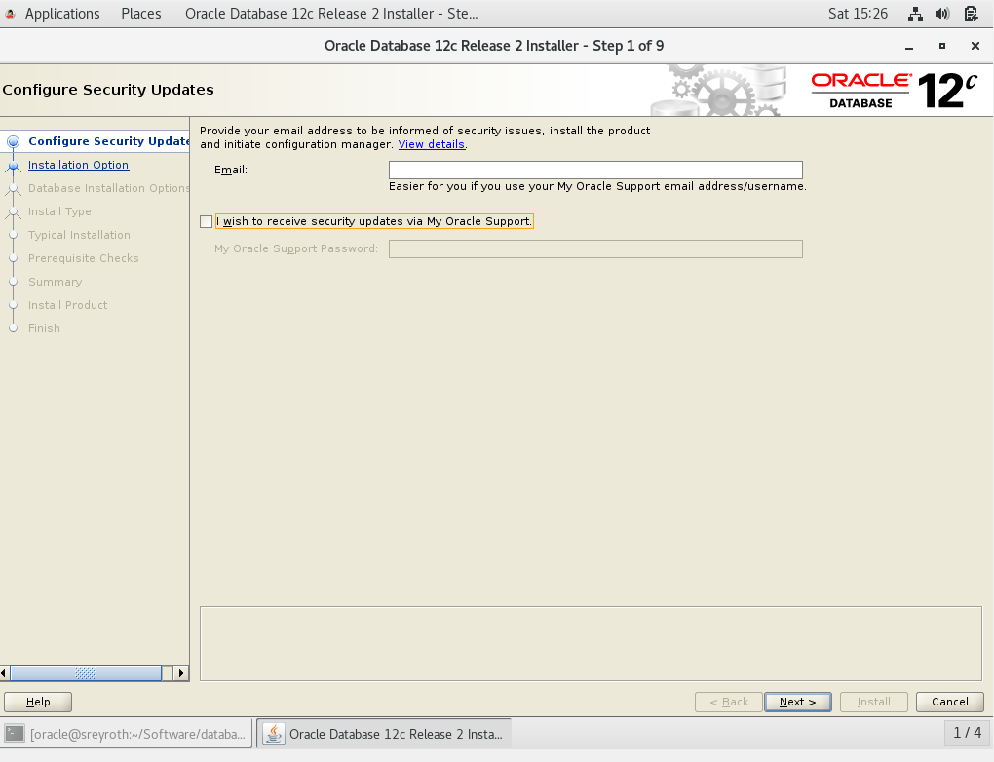

* Installation operation: Install database software only -> next

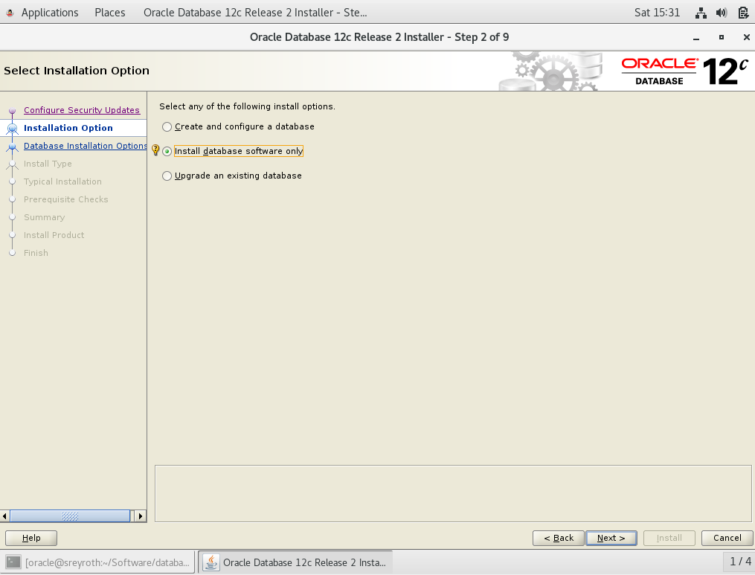

* 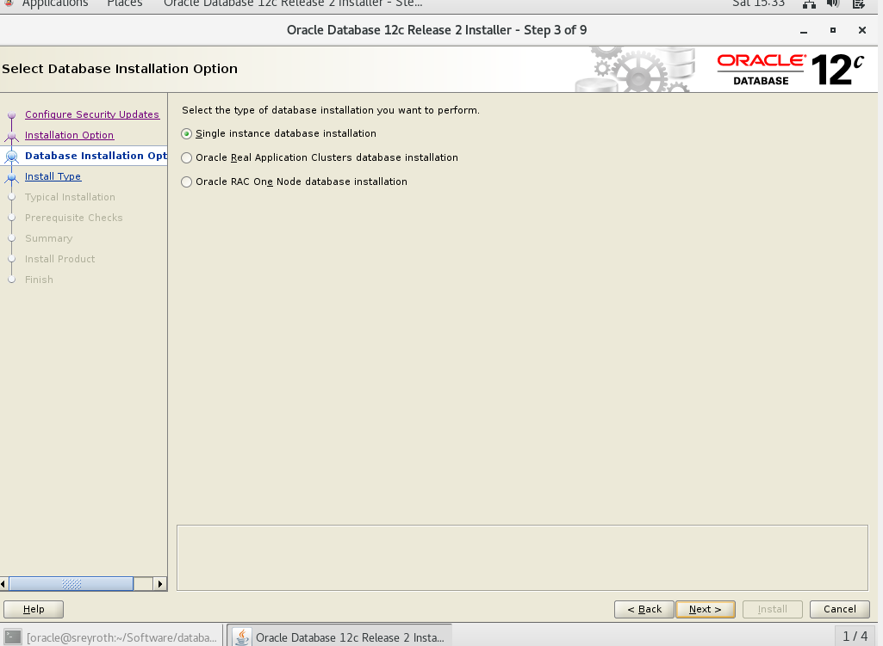Database installation option: Single instance database installation -> next
* 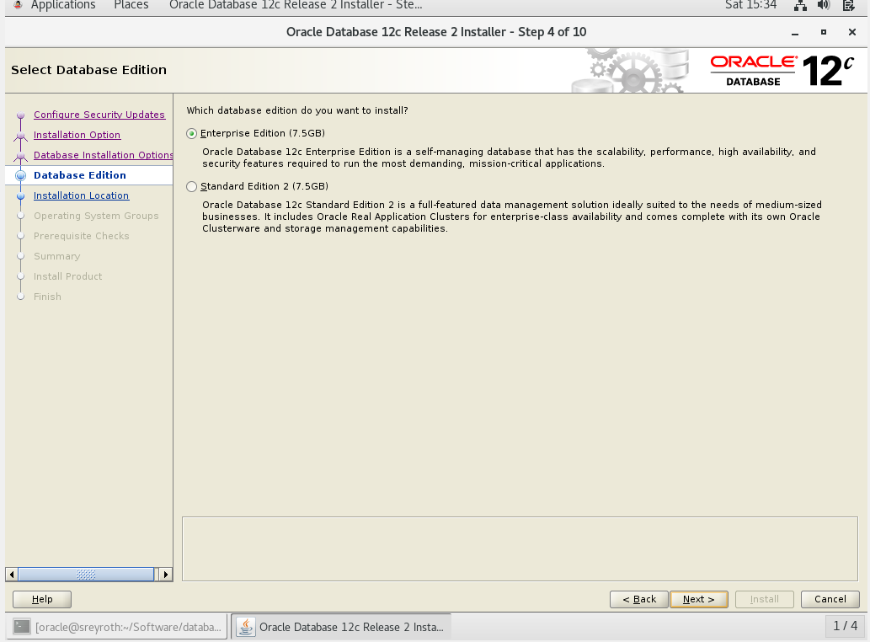Database edition: Enterprise Edition -> next

* Installation Location -> next

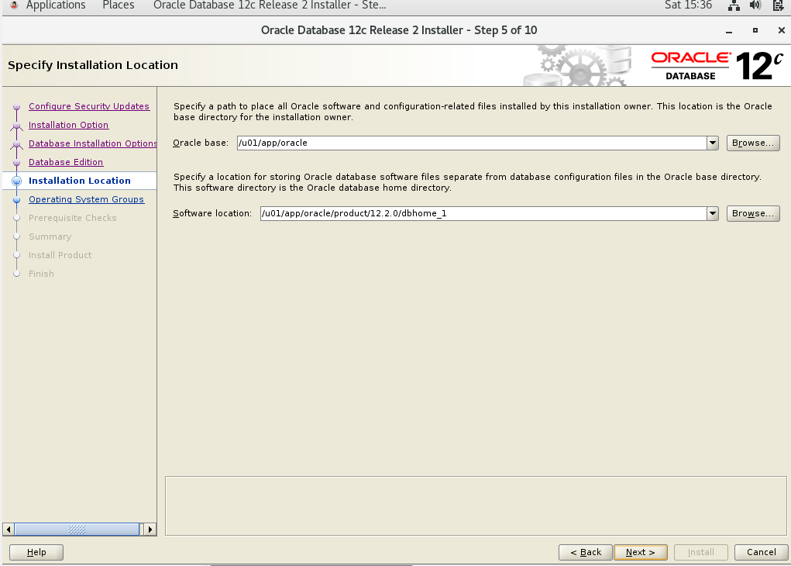

* Create Inventory

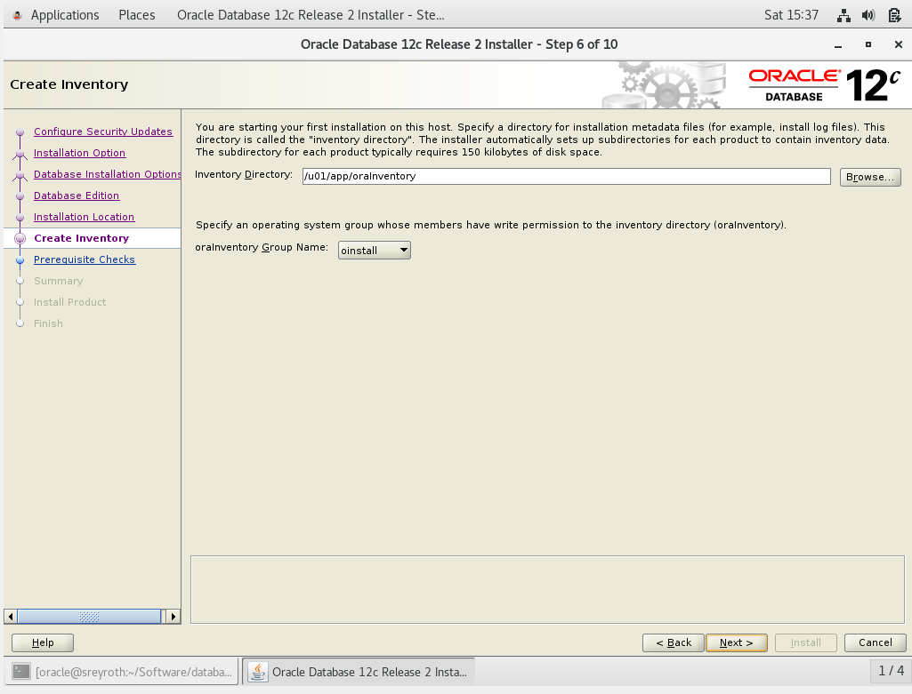

* 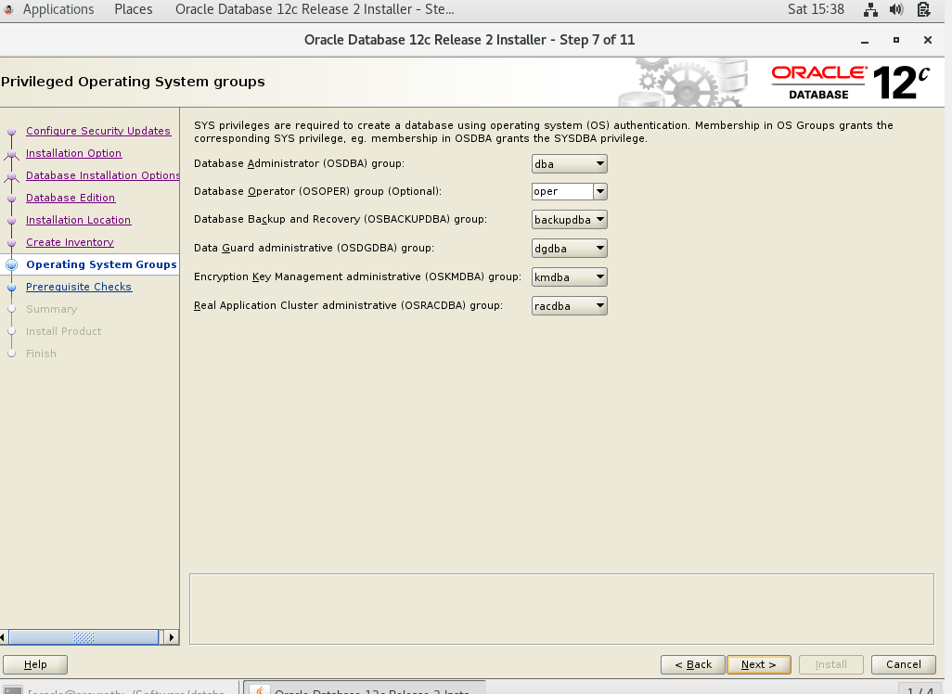Operating System Groups -> next

* 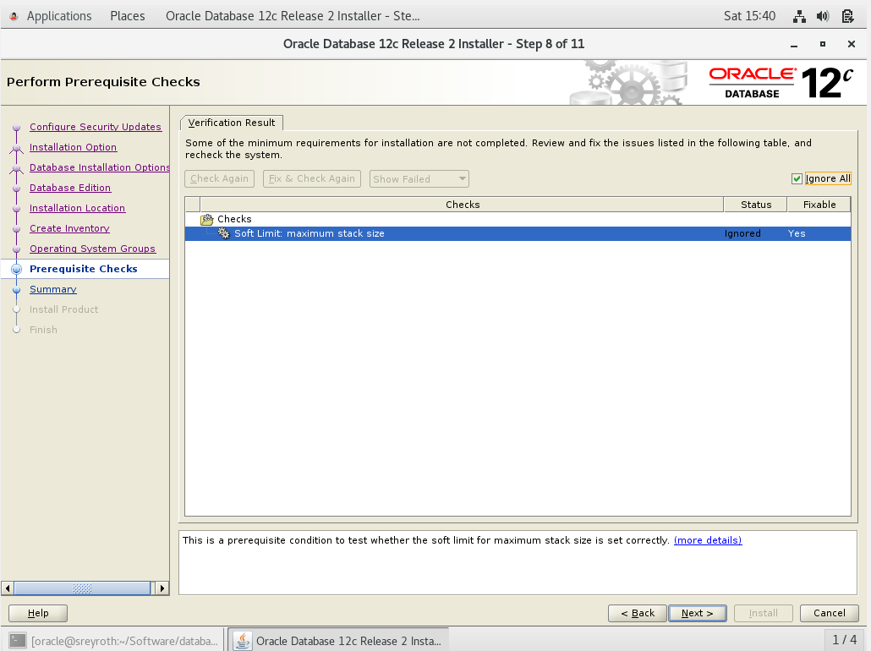Prerequisite Checks -> tick **Ignore All**
* Summary -> install

